Technology List Example

Category/Tool | Manufacturer | Model | Features
Digital Video Camera | Sony | TRV11 | -shoots to miniDV  -firewire output  -composite out  -headphone jack  -mic input  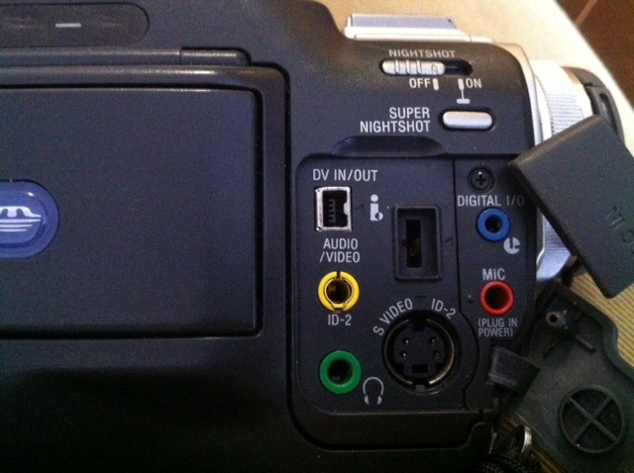
Digital Still Camera | Canon | Powershot A3400IS | -SD card  -16 megapixel with 4 image processor  - 3 inch touch panel display
Tripod | Manfrotto | 785B | -pistol grip
Microphone | Shure | SM48 | -XLR  -dynamic, unidirectional, cardiod, voice and vocal mic
Green screen / chroma key | Photofle | Flexdrop | -Reversible green/blue screen  - heavyweight stand  - 5 x 7 feet

